# Mobile View Draft Fall 2021

The objective here is to show that you have a good start on your site. The MOST important part is the content, followed by the navigation.

**Your name: Yue Wang**

**Link to your deployed site:** [**https://wyjessica860.github.io/final_project**](https://wyjessica860.github.io/final_project)

**For each navigation:**

**Index.html: Home, Breed.html: Breed, IF_1.html:Interesting facts, story.html: Movies, train.html: Discrimination**

(In most cases I would expect one sentence for each item. Tell peers what page to find what they are looking for, eg. how you are indicating the current page, etc.)

1. Do you have at least four pages that are linked via a common navigation bar?   
   Does the page have a common header and footer across all four pages?   
   Does each page have a unique title?
2. How do you indicate the current page WITHIN the links in the navigation? (Make sure you are not using just color)
3. Is the minimum content present? (Latin filler doesn’t count - it is important to be dealing with real content.) You should have have multiple images/paragraphs per page. We won’t be “counting” tags, just the visual appearance of a full page.

Does one page have at least nine (9) images?

1. Are you using **grid** on at least one page? It is probably rudimentary for just the mobile view, but that is okay. It may NOT be the same grid setup as HW5. Take a screenshot of your page with Inspect Element so that we can see the dotted lines of the grid and insert that picture here.  
   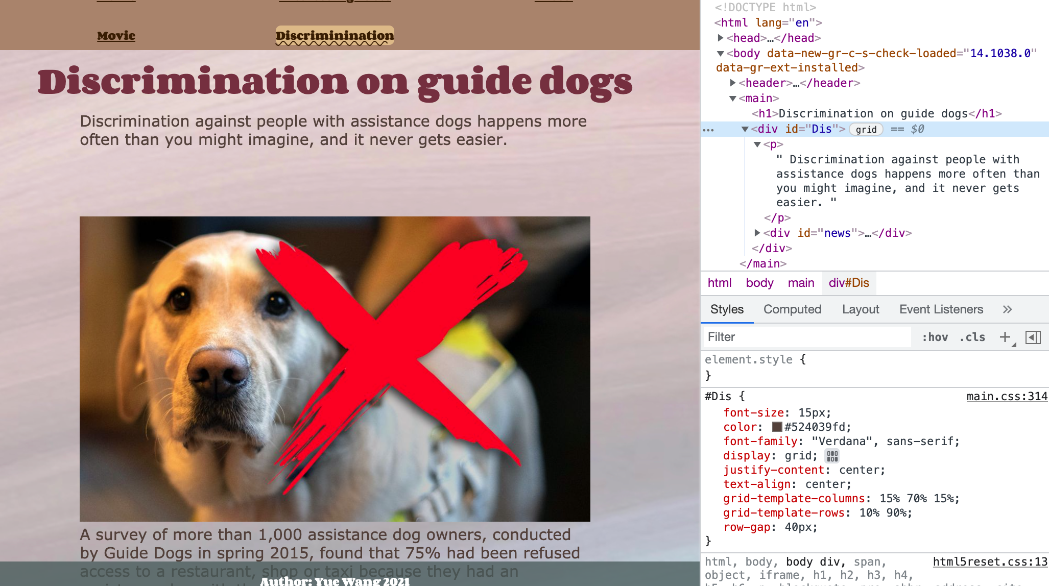
2. What did you do to make your pages particularly visually appealing? How did you come up with your color scheme? Tell us more about your font choices, image editing, etc. I am sure there are things that you did that we can't easily see. ***Make sure that you checked your site ON A PHONE***. We are looking for how it looks on a small screen.

1,beautiful color scheme and cute font family chosen. User friendly size chosen and grid distribution.

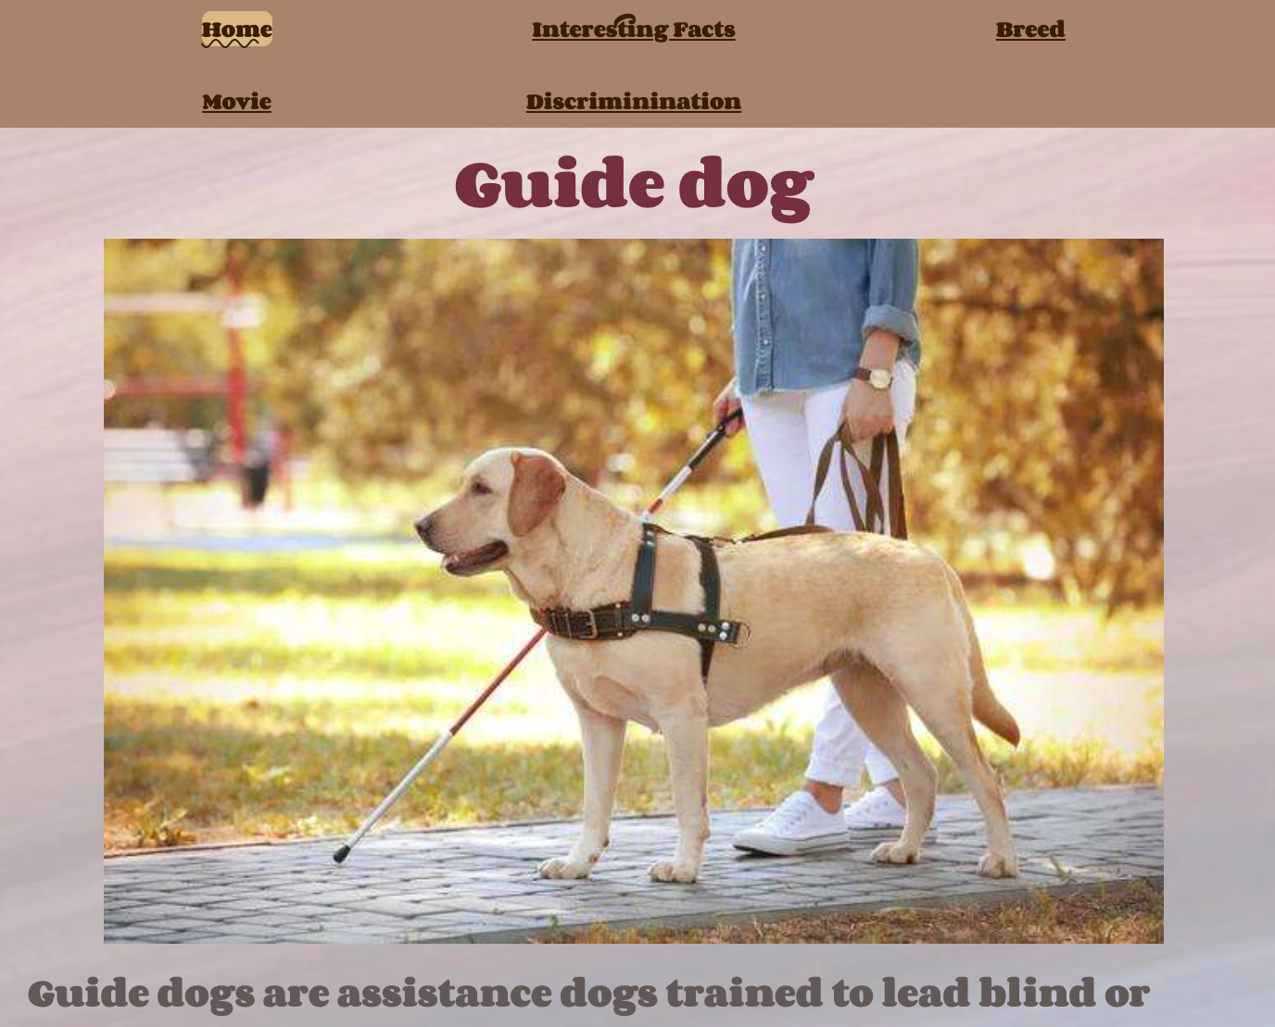

2, flip cards animation designing to add more interactivity

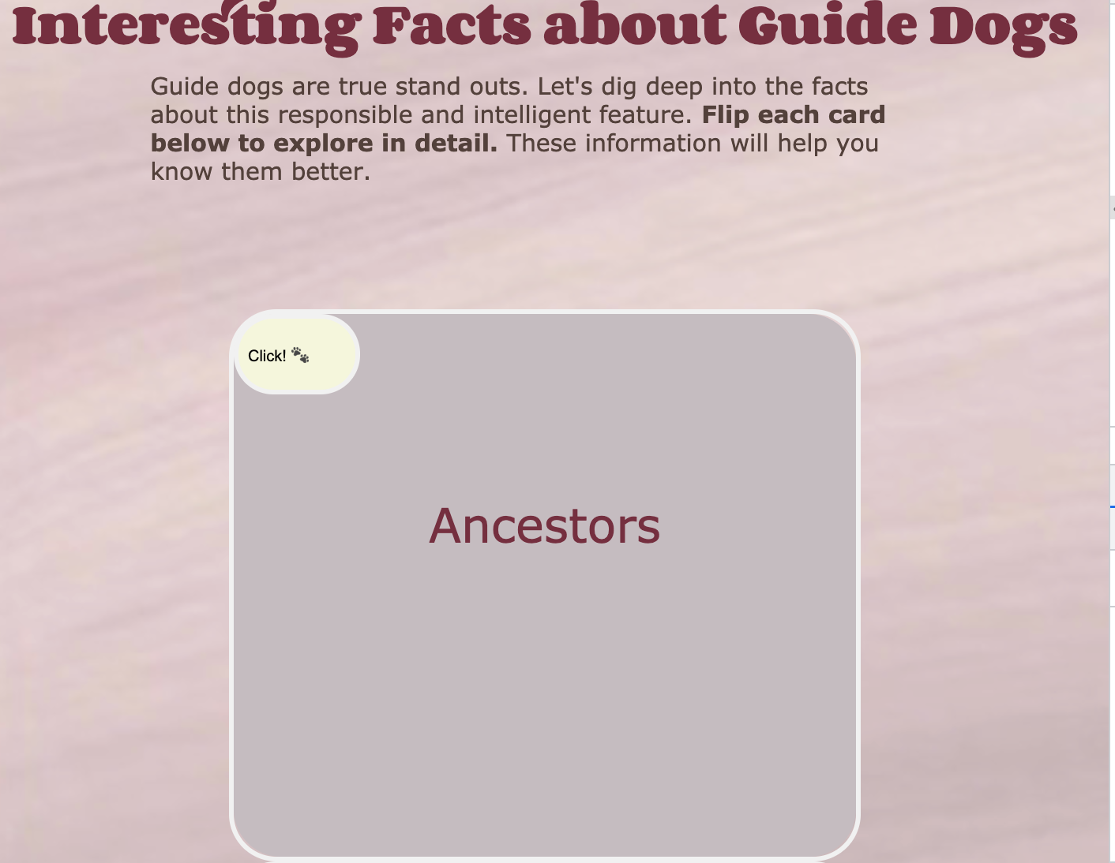

3, two interactive button added to construct a photo gallery: so that the photo is better organized

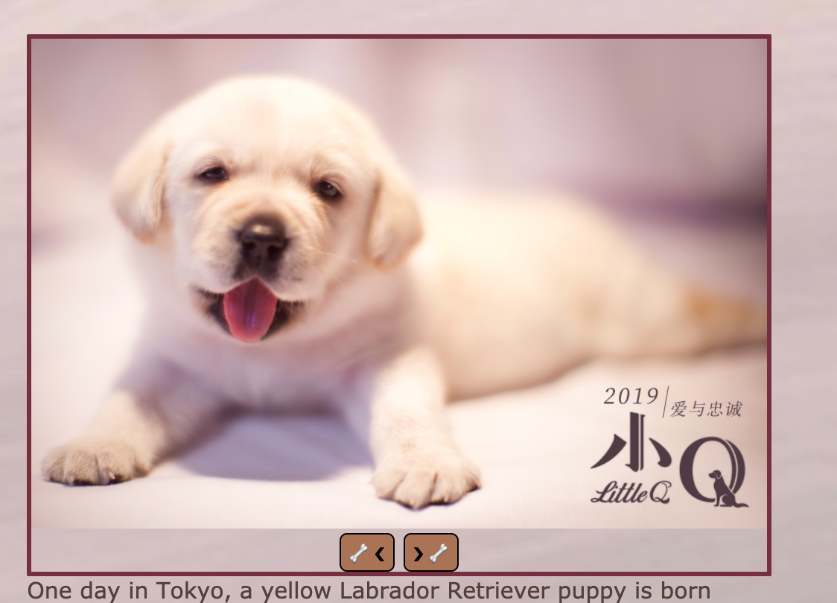

1. Validation - Include screenshots of your page validating on aXe and Wave. If you have errors that you don’t think should count against your grade, include documentation. You only need to show screenshots from two pages, not all four so a total of four screenshots.
2. 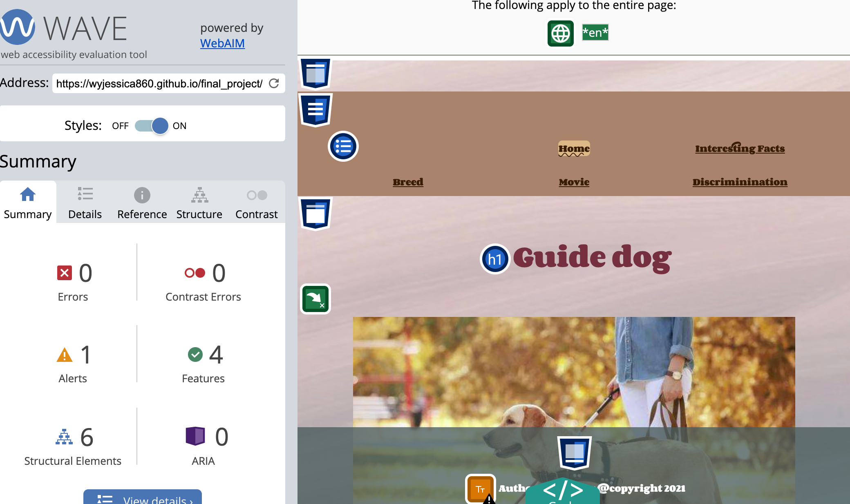
3. 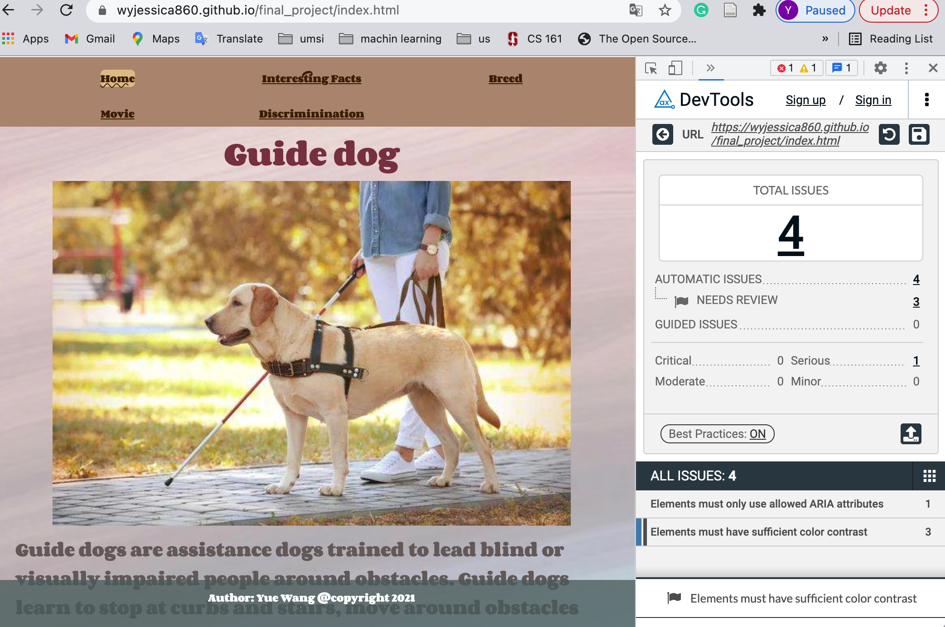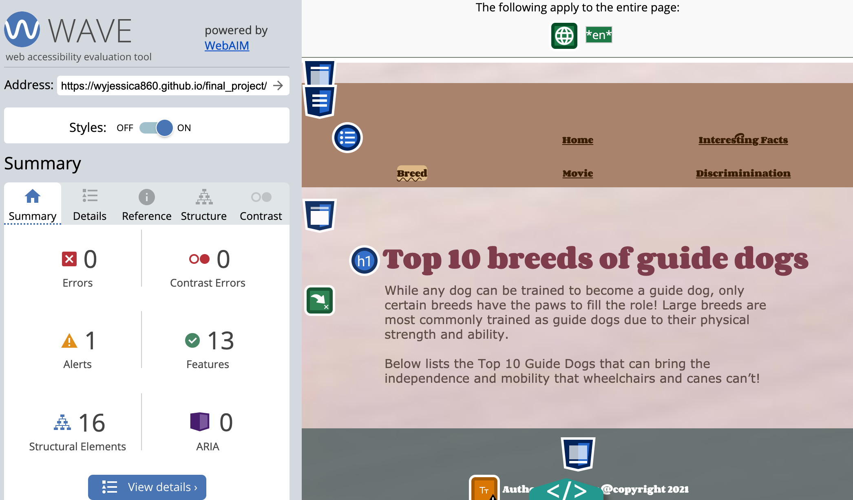
4. 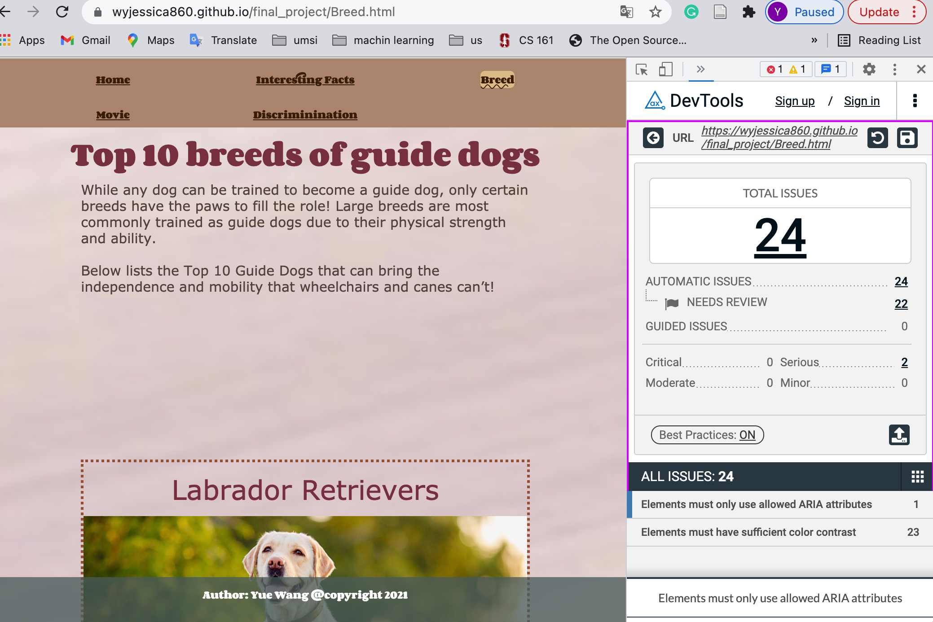

1. Check your site for other issues. Do you have console errors? Did you use proper naming conventions (no uppercase letters or spaces, mnemonic file names, etc.) Are you using the html5reset style stylesheet? Did you remember to include the viewport meta tag?

When you submit the link to this document in the comments section make sure that you have set the share permissions to allow anyone with the link to view and/or comment.